Java Project

Login Page

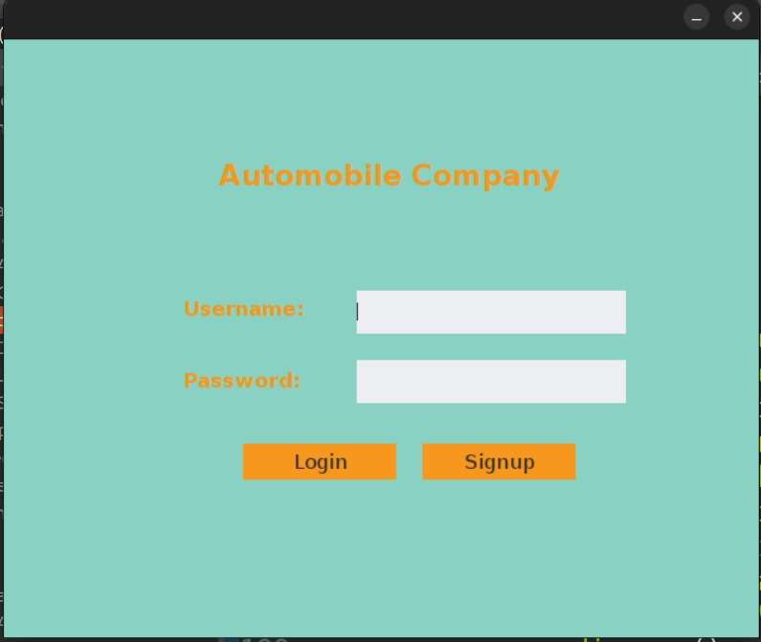

This is the Login page of Automobile Company. This has username and password text boxes. There are two buttons below them

1. Login button is to verify username and password.

2. Signup button is to create a new account.

Signup Page

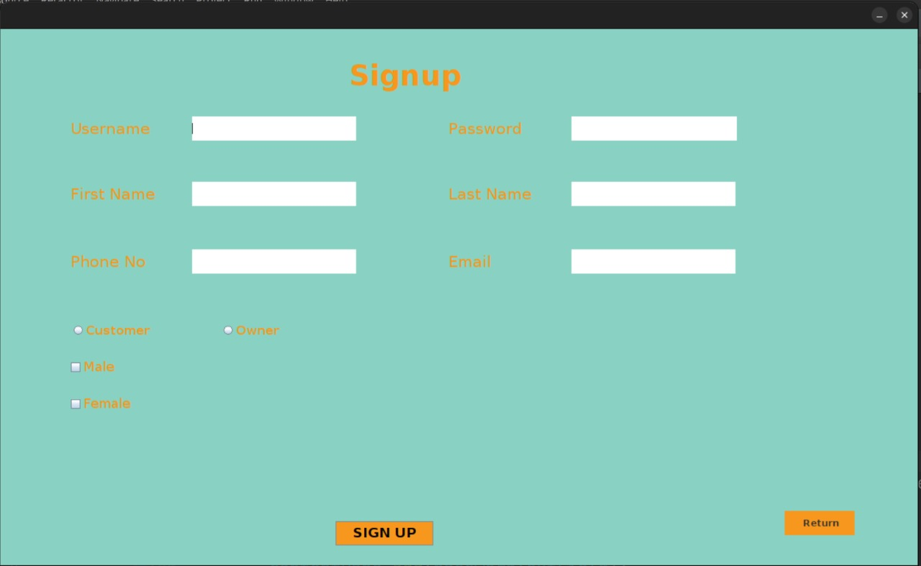

This is the Signup page of Automobile Company. This has Username, Password, First name, Last name, Phone no and Email text boxes. There are two buttons below them

1. Signup button is to create an account.

2. Return button is to go back to the login page.

There are two radial buttons to select whether you are the customer or the owner.

And there are two select boxes to select whether you are male or female.

Dealer Page

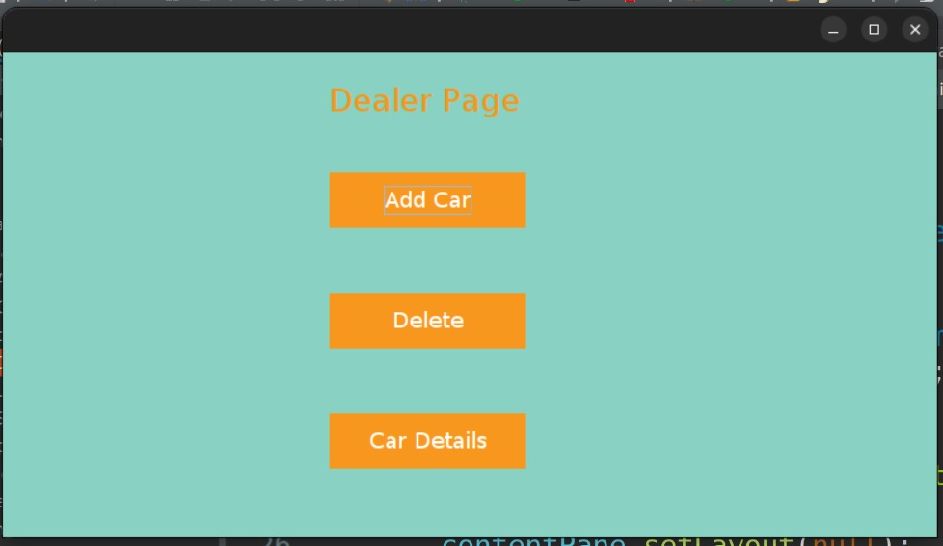

This is the Dealer page of Automobile Company. There are three buttons below them

1. Add Car button is to add cars by the dealer.

2. Delete button is to remove cars by the dealer

3. Car Details buttons is to view the details of the car by the dealer.

On clicking add car, delete car and view cars new page will be opened to adjust the cars owned by the Dealer.

Car Registration

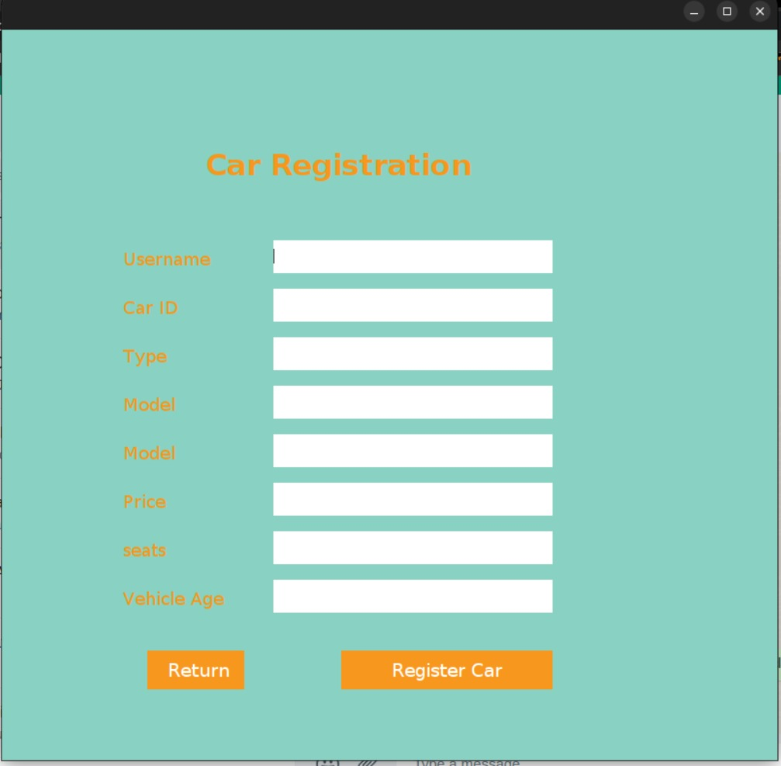

This is the Car Registration page of Automobile Company. This has Username, Car ID, Type, Model, Model, Price, Seats and Vehicle Age text boxes. There are two buttons below them

1. Return button is to go back to the Dealer Page.

2. Register Car button is to Car Registration.

Admin Page

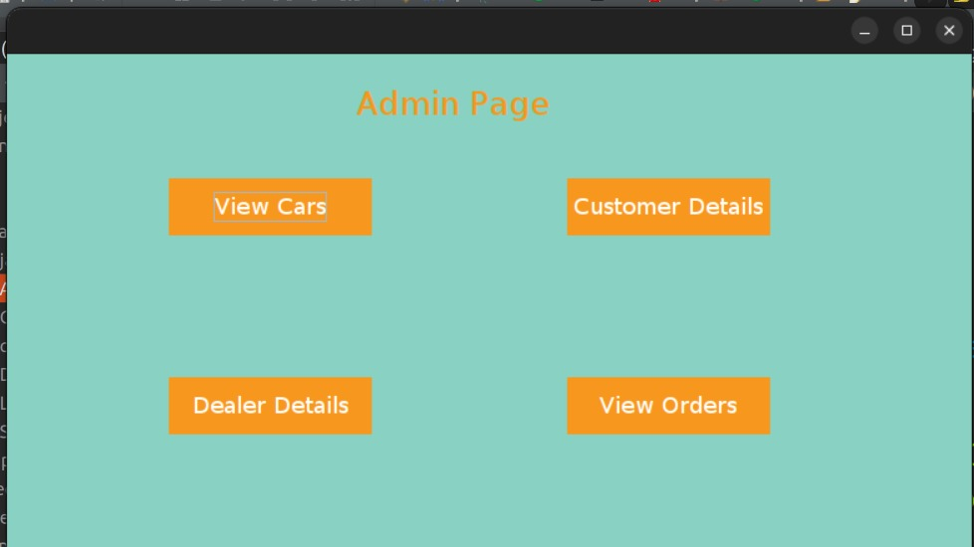

This is the Admin page of Automobile Company. There are four buttons below them

1. View Cars button is to view the cars by the admin.

2. Customer Details button is to view the details of the customer by the admin.

3. Dealer Details button is to view the details of the dealer by the admin.

4. View Orders button is to view the orders kept by the customer.

Customer Page

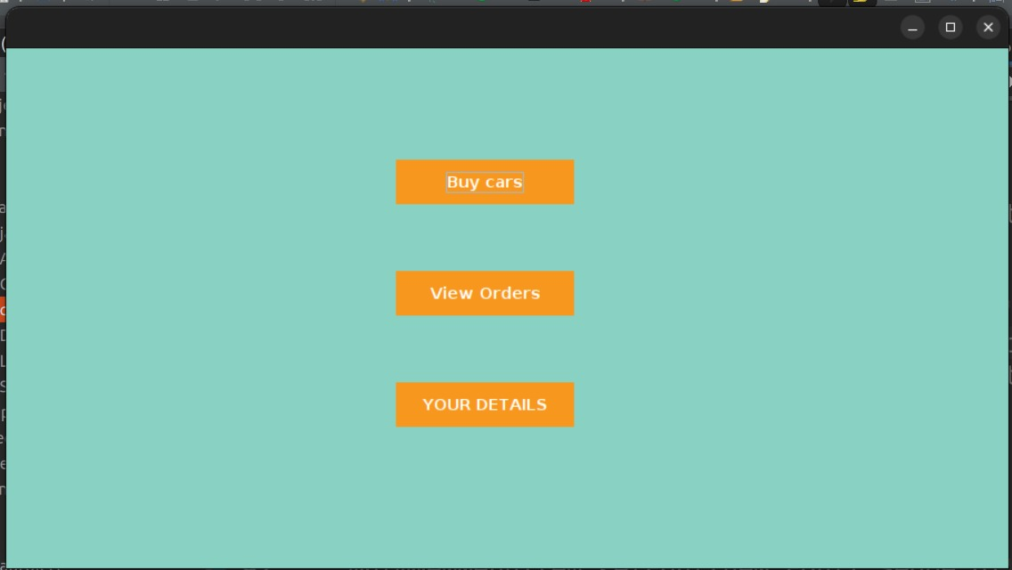

This is the Customer Page of Automobile Company. There are three buttons below them

1. Buy Cars button is to buy cars by the Customer.

2. View Orders button is to view the orders kept by him/her.

3. View Details button is to view the details or update the details of him/her.